Deep Learning Model using LSTM Network for Movie Genre Classification

**Adriyendi 1)[1]**

1)Information System, UIN Mahmud Yunus Batusangkar, Indonesia

1)[adriyendi@uinmybatusangkar.ac.id](mailto:adriyendi@uinmybatusangkar.ac.id)

|  |
| --- |
| *Abstract*  **Background:** The classification is for grouping sequence data collection files based on movie synopsis. There are many words in a sentence about the description of a movie to be processed manually. Therefore, we use the movie synopsis to determine the classification of movie genres.  **Objective:** Deep Learning (DL) uses a Long Short-Term Memory (LSTM) Network to classify movie genres based on synopsis.  **Methods:** Synopsis is described in the form of long sentences as sequence data. Sentences in a text are a series of words, which have dependencies between these words. To look for long-term dependencies in classifying sequence data, it is necessary to use the LSTM Network.  **Results:** The experimental results show that DL using the LSTM Network on sequencing data (synopsis) is able to produce category (3 genre) data quickly (30 epochs, 1830 iterations, 61 iterations per epoch, 50 frequencies).  **Conclusion:** Deep Learning (DL) uses the LSTM network to determine the successful classification of movie genres. The DL Model uses the stages of loading data, pre-processing data, converting documents, creating and training LSTM networks, specifying, training options, and predicting using new data. The implication is that DL using the LSTM network is able to produce a classification of movie genres based on the movie synopsis. This means that the input is in the form of sequence data, processed with deep learning and produces output in the form of array category data on predicted time series data.  ***Keywords:***Deep learning, long-short term memory, movie, classification  ***Article history:***Received 5 April 20XX, first decision 22 April 20XX, accepted 22 August 20XX, available online 28 October 20XX |

Introduction

Deep Learning (DL) is a sub-field of machine learning and neural networks. There are two types of neural networks, namely ordinary neural networks and deep neural networks. An ordinary neural network is a single network with an input layer, an output layer and a hidden layer. A deep neural network consists of several neural networks where the output of one network is the input to the next network. This concept can overcome the limited number of hidden layers in ordinary neural networks and is able to work well on big data [1]. DL uses the composition of multiple nonlinear functions to model complex dependencies between input features and labels. DL reveals complex nonlinearity through constructing many nonlinear functions. The statistical performance of a neural network is highly dependent on the optimization algorithm used for training. Deep neural networks that are trained with only raw data input can provide useful data representations [2]. DL models have influenced the process of text classification. This model is capable of modeling complex features by eliminating some of the domain knowledge requirements. This model leads to the development of neural network architectures capable of extracting effective representations for textual units. Recent developments have given rise to representations that are semantically and contextually meaningful. Automatic feature extraction is very beneficial in modeling textual data, because it is able to take advantage of the underlying linguistic structure of a document [3].

DL is the development of multiple layers of neurons to provide precise tasks such as sequential text data. Text is a sequence of words that have dependencies between them. To find long-term dependencies in classifying sequence data, it is necessary to use a Recurrent Neural Network (RNN). LSTM (Long Short-Term Memory) is part of RNN. Superior LSTM networks operate on sequential data. The LSTM network is also capable of capturing long-term dependencies between word-for-word sequences [4]. The LSTM model addresses long-term dependencies between words in sentences. The advantage of LSTM is the remote dependencies captured by the LSTM model. LSTM is a subset of Recurrent Neural Network (RNN). LSTM is able to predict word for word based on previously stored information. The order of words in a long text in a data sequence such as a film synopsis is important for the audience to know a film in a short time. A good film synopsis should reflect the genre, structure, and main plot of a particular film. The aim of this paper is to use machine learning to identify film genres through film synopsis. Due to the large amount of sequential text data about film synopsis that is generated, shared, and transferred every day on the internet, data analysis is important for developing a classification system [5]. This paper introduces data analysis on sequence data classification using deep learning networks. The classification is for grouping sequence data collection files based on film synopsis. There are many words in a sentence about the description of a film to be processed manually. Therefore, we use the film synopsis to determine the classification of film genres. This classification uses deep learning by applying the LSTM model. For the experiment, we used a data set on descriptions from film synopsis (Indonesia movie review from Kaggle) and divided the data into a training set and a testing set.

*The contribution of this research in brief:* the learning process using the DL Model produces class distribution, word cloud, token document, and document length. The network training process using the LSTM Model produces arrays, layers, and labels. The classification process using the Framework Model (DL Model and LSTM Model) produces categorical data in the form of a class.

Literature Review

Multi-label text classification has several genres at once in the topic of movie genre classification. The parameters used for this classification are the movie plot, title, summary, and subtitles. In this paper, the movie genre classification method uses a combination of binary relevance techniques, powerset labels, text vectors and classifier models. Binary relevance (BR) technique was performed to convert a multi-label classification assignment into an independent binary classification assignment. The powerset label technique turns a multi-label problem into a multiclass problem. Multiclass classifiers are trained on all unique label combinations in the training data. Vocabulary is made by marking text data using count vectorizer and term frequency to inverse document frequency [6]. This paper aims to classify movie into the appropriate genres. There are three methods used; the first uses a movie plot, the second uses a movie title, and the third uses a combination of movie plots and movie titles. The data used includes titles, summaries, and tags with pre-processing techniques. Then, this data is forwarded to the Bidirectional Long Short-Term Memory (Bi-LSTM) model to classify movie into the appropriate genre [7]. This study uses two machine learning models (k-NN and SVM) and two deep learning models (CNN and RNN) to classify movie genres through movie synopsis. Movies and their corresponding synopsis in the database are downloaded from the websites of Kaggle and Rotten Tomatoes. Furthermore, this research attempts to eliminate interference by actively eliminating appropriate nouns. Finally, this research compares and analyzes the performance of all models in different training sets. The result is that the RNN with the LSTM layer is the most suitable model for analyzing large amounts of text for film synopsis, and the accuracy of movie genre categories [8].

Classification of movie genres using a multimodal strategy for multi-label scenarios. This dataset uses parameters: poster, synopsis, subtitles and trailer. Each medium is used deep network. This classification uses two final fusion models and strategies [9]. This paper uses multimodal on multi-label classification of movie genres. The movie dataset is sourced from trailer, subtitle, synopsis, and poster video clips. In this paper, we discuss the multi-label classification of movie genres in a multimodal way. For this purpose, we created a data set consisting of movie trailer clips, subtitles, synopsis and movie posters. This paper uses descriptors such as Mel Frequency Cepstral Coefficients (MFCCs), Statistical Spectrum Descriptors (SSD), and Local Binary Patterns (LBP). This descriptor is capable of training monolithic classifiers using Binary-Relevance and ML-KNN techniques. Apart from that, a combination of classifiers and features was also made using the late fusion strategy [10]. An algorithm for genre detection has been proposed to be built on unused film subtitles which are a documented account of the visual content and dialogue of the movie. Identify word for word that has a high frequency in a particular genre and use it as a feature to train the learning model on classification. Algorithm performance tested on English subtitles. Classification is carried out for learning models with a varied number of features [11]. This paper discusses the review of models and techniques in carrying out genre-based classification. This classification is divided into domains: detection, features, and mining. This domain includes various classification techniques: two-way techniques, gram layers, and scene categorization [12]. This paper presents the results of predicting film genres using movie trailers based on visual, textual and metadata. Trailers are selected with key characteristics and divide them into specific genres. The relevant information from the movie dataset is poster, plot, trailer and metadata. The algorithms used in this paper are K-Nearest Neighbors, Linear Regression, Decision Tree, and Random Forest [13]. This is paper discusses word representation using Facebook's Quick text model library. This model uses a Bi-LSTM network and rating system. This depends on the posterior probability score in determining the movie genre. This paper divides the plot summary into several sentences and predicts the genre associated with each sentence. This model combines the decisions of all sentences to make a collective decision for a particular plot summary. This model uses a majority voting algorithm to make the final decision. This paper uses a document level and sentence level approach to predict film genre [14]. In this paper, a classification of film genres is made using the Hybrid Fusion Network (HFN) model. This model uses three fusion networks. First, a fusion network with single modal features for video and audio. Both feature multi-modal fusion networks based on shots. All three end fusion networks for video level decisions. The performance of the audio auxiliary modality is a major contribution in an effective ablation of film genre classification [15]. The combination of Natural Language Processing (NLP) and deep learning has been successful and he is able to classify subtitle genres that have more than one genre. This classification is used to classify text data into their genres while at the same time calculating the weight of the existence of genres in the text. This paper uses deep neural networks and NLP for the problem of movie classification. This classification uses a film script based on the classification of each scene [16].

Methods

The collection of data into datasets includes single-label, multi-label, unsupervised, and unbalanced data in the text classification model. Text classification takes some type of text as input. The text is represented as a vector by the pre-training model. Text representation aims to express pre-processed text and minimize information loss [17].

Fig. 1. Structure of Deep Learning

Deep Learning requires a large amount of training data with the same number of parameters. Long-short term memory network (LSTM) is a subset of recurrent neural networks or RNNs. LSTM advanced in sequential data operations, being able to predict words based on past information, information that has been stored for a long time, and delete information that is no longer relevant. LSTM is more efficient in carrying out classifications based on a certain time sequence [18].

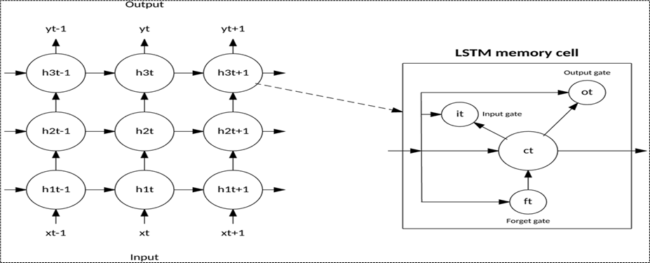

Fig. 2. Structure of LSTM Network

The Long Short-Term Memory (LSTM) network has been expanded to transfer learning. Specifically, an LSTM with 6 layers: token embedding layer, character embedding layer, character LSTM layer, token LSTM layer, fully connected layer and sequence optimization layer [19]. LSTM has gates: forget gate, input gate, and output gate. First, the forget gate functions to remove some irrelevant and unnecessary information. This gate function can display a complete, actual and appropriate set of information. Second, the input gate is responsible for entering useful information to support the accuracy of the data. This task is to add previously selected information through the forget gate. In the input gate then known as the input modulation gate. The input modulation gate functions to modulate the existing information, thereby reducing the convergence speed. Third, the output gate whose job is to produce information about complete and actual data [20].

Fig. 3. Deep Learning Model

In deep learning, a computer will study various models and classify their tasks based on the data collected. The data can be sequential text data (sequence data). Deep learning automatically represents data sequences without introducing code rules or human domain knowledge. Deep learning is used to facilitate activities with the help of machines and artificial intelligence. Deep learning was created to make the performance of unstructured data more optimal in an application. Deep learning can be interpreted as a technique in machine learning that directs a computer or machine system to work like a natural human, namely by studying situations with certain learning or programming. Classified data objects are problems that often arise in the classification process. Data is represented features with appropriate labels to obtain accuracy in performing classification [21].

Fig. 4. LSTM Model

Steps in using the LSTM network are first, convert the text data into a numeric sequence. This can be done using word encodings which map documents to a sequence of numeric indexes. Second, insert the word insert layer or embed the word in the network. Third, word embedding to map words in the vocabulary to numeric vectors. Fourth, embedding words to capture semantic details from word to word. This means that words with the same meaning have similar vectors. It is necessary to model the relationship between words through vector arithmetic.

Fig. 5. Framework Model

Most of the deep learning works using the neural network method. This is also called deep neural networks, which work on a large number of levels or layers. As an illustration, traditional neural networks only have 2-3 layers available. Meanwhile, for deep neural networks there are more than 150 layers. Deep Neural Networks (DNNs) consist of artificial neural networks that simulate the human brain to automatically learn high-level features from data.

# Results and Discussion

Load Data

Import data by inputting sequential text data (sequence data). This data contains textual descriptions with specific labels (Indonesia movie dataset, csv format, 8 x 11 table, and 1273 record form Kaggle). To import this text data by changing the text type to 'string'. The results are shown in Table 1.

TABLE 1

Load Data

|  |  |  |
| --- | --- | --- |
| No | | Synopsis |
| 1 | Ayudia (Mawar De Jongh) is not satisfied enough in enjoying the moment as a wife, but she suddenly becomes pregnant. Her personality changes completely and becomes lazy and super sensitive | |
| 2 | After apparent death, Siena is able to see signs that people will die. However, her friends did not believe in her abilities. Then, the sign appeared on her and those closest to her | |
| 3 | Alfi (Al Ghazali) meets Alana (Caitlin Halderman), a new student at school. It turns out that they are in one class and sitting next to each other. Instead of getting along, they often argue because they both are stubborn | |
| 4 | This movie tells the story of Hanif Thamrin (Adipati Dolken) leaving his hometown and trying to pursue his dream to become the only Indonesian at that time who works in the biggest soccer league in the world, English Premier League | |
| 5 | Sara, Airin, Rachel, and Amara were accidentally brought together after the death of their ex, Alex. All four received a letter saying that there was one killer among them | |
| 6 | Good-Morning Indonesia, a school for poor orphans, invites seven children to become a team, but, jealousy and envy started because of the hidden love between them. They are sent to Europe without accompany, and the conflicts are exploded | |
| 7 | When staff salaries get stolen at his school, a reluctant new teacher sets out to recoup the money and soon discovers the joys of teaching | |
| 8 | Randu (Reuben Elishama Hadju) and Dinar (Jill Gladys) are happy because Dinar conceives for the fourth month. However, their happiness slowly disappears when a middle-aged woman, Sukma | |

Import

Import data by inputting sequential text data (sequence data). This data contains textual descriptions with specific labels (Indonesia movie dataset, csv format, 8 x 11 table, and 1273 record form Kaggle). To import this text data by changing the text type to 'string'. The results are shown in Figure 6.

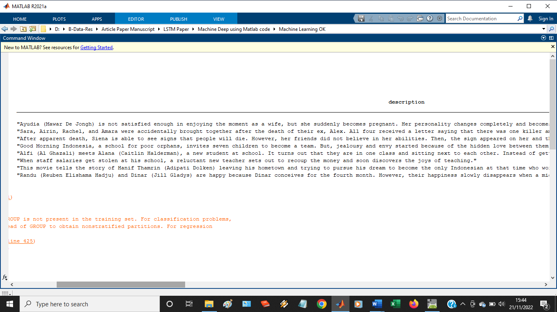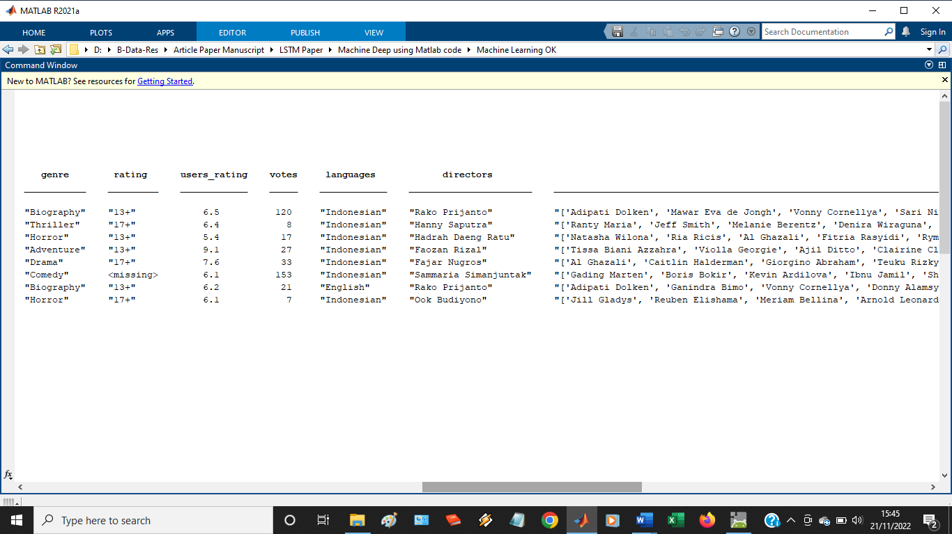

(a) (b)

Fig. 6. Classify (a) Description, (b) Genre

Distribution

Distribution is done to partition the data into sets for training and sets for validation. Class distribution in the partition results data is displayed using a histogram in Figure 7.



Fig. 7. Class Distribution

Partition

Partition is a step to divide the set for training and set for validation. Data partition into (training partition) and partition out (held out partition) for validation and testing. Partition is done by determining the holdout percentage to 20%.

Extraction

Extraction is a step to decipher text data and labels from the partition table.

Visualization

Visualization to check whether the data has been entered correctly and the results are displayed using a word cloud shown in Figure 8.



Fig. 8. Visualization of Training Data in Word Cloud

## Pre-process Data

### Tokenize

Tokenization to mark and pre-process text data. Tokenization using the tokenized document function.

Conversion

Conversion is performed to change text to lowercase using the lower function. Pre-processing for training data and validation data uses the pre-process text function.

Erase

Activity of erasing punctuation using erase Punctuation based on pre-processing training. The results of this process are shown in Figure 9.

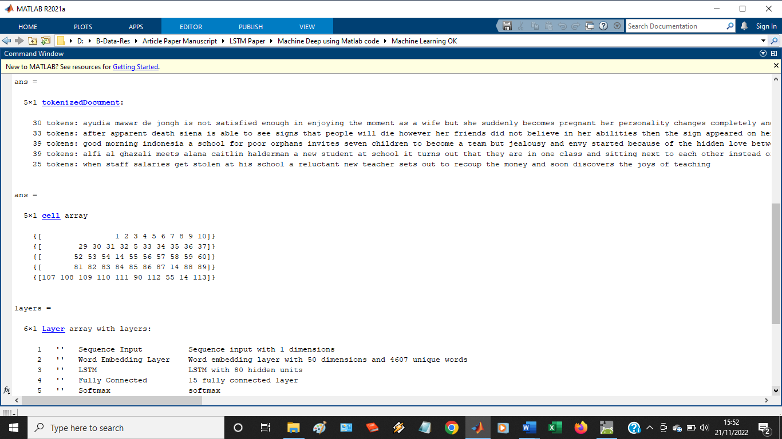

Fig. 9. Tokenized Document

## Convert Document

### Input

The stages of inputting sequence data into the LSTM Network by using the Encoding function. This function is to convert the document into a sequence of numeric indexes. This is done to make the word encoding.

Truncate

### The next step is padding and cropping (truncate) the documents so they are the same length. This process uses the Options function. This function provides options to layer and trim the input sequence automatically.

Lengths

To overlay pads and cut documents, select a target length and trim documents that are longer than the target. The pad on the left side of the document is shorter than the target. therefore, the target length should be shorter without wasting large amounts of data based on the corresponding target length of the training document length histogram shown in Figure 10.



### Fig. 10. Document Lengths

Indices

### Indices on most training documents have less than 10 tokens. It can be used this as a target length for truncation and padding. Convert document to numeric index sequence using doc2sequence. To truncate or leave the sequence to have a length of 10, set the 'Length' option to 10.

Validation

### Validation is done by changing the validation document into a sequence using the same options.

Create and Train LSTM Network

### Sequence Input

The first stage is to create an LSTM network and determine the network architecture. To feed sequence data into an LSTM network, also include the sequence input layer and set the input size to 1.

Word Embedding Layer

Next, include a word insertion layer with dimensions of 50 and the same number of words as the word encoding.

### Long Short-Term Memory

Next, also include the LSTM layer and set the number of hidden units to 80.

Fully Connected

### Next, include an LSTM Layer for the sequence-to-label classification problem by setting the output mode to 'last' and add a fully connected layer with the same size as the number of classes.

Soft-max

Next, add a soft-max layer.

### Classification Output

### Lastly, add a classification layer.

Specify Training Option

### Train

Set training options: Practice using Adam's breaker.

Specify 1

Define mini-batch sizes of 16.

### Shuffle

Shake the data for each epoch.

Monitor

### Monitor training progress by setting the 'Plot' option to 'training progress'

Specify 2

Define validation data using the 'Data Validation' option.

Suppress

Suppress verbose output by setting the 'Verbose' option to false.

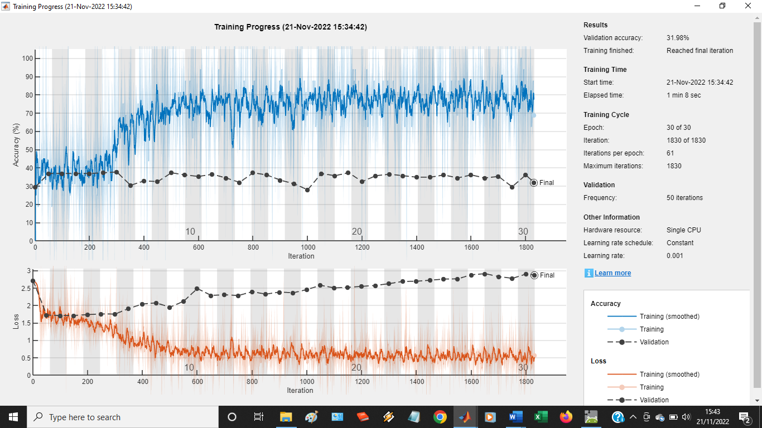

Fig. 11. Progress Training

Predict New Data

### Classify 1

Grouping film genre categories from three descriptions (new synopsis) by creating a string array whose contents of the new synopsis are shown in Table 2.

TABLE 2

New Classification

|  |  |
| --- | --- |
| Synopsis | Genre |
| Joined by lizard pilot and rabbit magician, a mouse detective tries to find a missing device meant to provide clean energy for his city (Movie: Titus mysterious of the enigma) | ? |
| Harboring a deep secret, a seemingly happy family confronts the trauma of years past a clash between generations threatens to separate them (Movie: one day will talk about day 2020) | ? |
| Siena is able to see signs that the people will die. The sign appeared on Brama’, someone she loves. Siena tries hard to prevent Brama’s death (Movie: I know when you dead 2020) | ? |

Pre-process

Pre-processing of text data by means of pre-processing steps as training documents.

### Convert

Convert text data to sequences using doc2sequence sequences with the same options as when creating training sequences.

Classify 2

### New sequence classification using a trained LSTM network.

|  |  |  |
| --- | --- | --- |
| (a) | (b) | (c) |

Fig. 12. Class of Movie Genre, (a) array, (b) layer, (c) label

Class of movie consists of 3 group: array (5 x 1 cell), layer (6 x 1 layer), and label (3 x 1 categorical). Predict new data in 3 labels (romance, adventure, horror).

Conclusions

Deep Learning (DL) uses the LSTM network to determine the successful classification of movie genres. The DL Model uses the stages of loading data, pre-processing data, converting documents, creating and training LSTM networks, specifying, training options, and predicting using new data. In the distribution process using partitions (data training and data testing) produces a class distribution. At the extraction stage (text and label data) displays training data with visualization in the form of a word cloud. In pre-processing data generate tokens. At the convert document stage (encoding function, option function, doc2sequence) produces Document Length. The LSTM network model uses the stages of loading and pre-processing data, creating and training networks, and converting the words. The Framework Model is a combination of the DL model and the LSTM model. The LSTM network produces arrays (5x1 cells), layers (6x1 layers), and labels (3x1 categorical arrays). The experimental results show that Deep Learning using the LSTM Network on sequence data is able to produce good movie genre 3 categories (epoch 30, iteration 1830, iterations per epoch 61, frequency 50). The implication is that deep learning using the LSTM network is able to produce a classification of movie genres based on the film's synopsis. This means that the input is sequenced data, processed with deep learning and produces output in the form of categorical data on predicted time series data.

**Author Contributions:** *[Adriyendi]*: Conceptualization, Methodology, Writing - Original Draft, Writing - Review & Editing, Supervision.

**Funding:** This research received no specific grant from any funding agency.

**Conflicts of Interest:** The authors declare no conflict of interest.

**ORCID**:

First Author: <https://orcid.org/0000-0001-7335-6882>

References

1. H. Setyabudi, I. H. Kartowisastro, A. Trisetyarso, and E. Abdurrahman, “Evaluation of real options valuation of petroleum using deep learning algorithms based on crude oil futures information with dual information,” *Int. Sem. on App. for Tech. of Inf. and Comm.,* pp. 1-17, 2022. doi: 10.1109/iSemantic55962.9920405.
2. J. Fan, C. Ma, and Y. Zhong, “A selective overview of deep learning,” *Stat. Sci.,* nol. 36, no. 2, pp. 264–290, 2021. doi:10.1214/20-sts783.
3. A, Gasparetto, M. Marcuzzo, A. Zangari, and A. Albarelli, “A survey on text classification algorithms: from text to predictions,” *Information,* vol. 13, no. 83, pp. 1-38, 2022. doi:10.3390/info13020083.
4. K. Dashtipour, M. Gogate, A. Adeel, H. Larijani, and A. Hussain, “Sentiment analysis of persian movie reviews using deep learning,” *Entropy,* vol. 23, no. 5, pp. 1-16, 2021. doi:/10.3390/e23050596.
5. S. M. M. Hossain, J. A. Sumon, M. I. Alam, K. M. D. A. Kamal, A. Sen, and I. H. Sarker, “Classifying sentiment from movie reviews using deep neural network,” *Int. Conf. on Intell. Comp. & Opt.,* pp. 399-409, 2022. doi: 10.1007/978-3-031-19958_5_37.
6. S. Kumar, N. Kumar, A. Dev, and S. Naorem, “Movie genre classification using binary relevance, label powerset, and machine learning classifiers,” *Multi. Tools and App.*, vol. 87, pp. 1-24, 2022. doi:10.1007/s11042-022-13211-5.
7. S. Devarasettym, V. Varsha, C. R. G. Reddy, and H. R. Mamatha, “Predicting of movie genres based on its synopsis and title using bi-lstm,” *Mod. Appr. in Mach. Learn. & Cog. Sci.,* pp. 173-179, 2022. doi:10.1007/978-3-030-96634-8_15.
8. J. Wang, “Using machine learning to identify movie genres through online movie synopsis,” *Int. Conf. on Inf. Tech. and Comp. App.,* pp. 1-6, 2020. doi: 10.1109/ITCA52113.2020.00008.
9. M. A. D. Paulino, Y. M. G. Costa, and V. D. Feltrim, “Evaluating multimodal strategies for mult-label movie genre classification,” *Int. Conf. on Sys., Sig. and Image Proc.,* pp. 1-4, 2022. doi: 10.1109/ ITCA52113,2020.00008.
10. R. B. Mangolin, R. M. Pereira, A. S. Britto, C. N. Silla, and V. D. Feltrim, “A multimodal approach for multi-label movie genre classification,” *Multi. Tools and App.,* vol. 81, pp. 1-26, 2020. doi:10.1007/s11042-020-10086-2.
11. N. K. Rajput and B. A. Grover, “A multi-label movie genre classification scheme based on the movie’s subtitles,” *Multi. Tools and App.,* vol. 81, pp. 32469–32490, 2022. doi:10.1007/s11042-022-12961-6.
12. A. S. Mehal, K. Meena, R. B. Singh, and P. G. Shambharkar, “Movie genres and beyond: an analytical survey of classification techniques,” *Int. Conf. on Trends in Elect. and Inf.*, pp. 1193-1198, 2021. doi: 10.1109/ICOEI51242.2021.9453021.
13. A. K. Jha, A. Batra, A. Dubey, D. K. Vishwakarma, “Multimodal and multilabel genre classification of movie trailers,” *Int. Conf. on Sust. Comp. and Data Comm. Sys.,* pp. 1641-1646, 2022. doi: 10.1109/ ICSCDS53736.2022.9760773.
14. P. Srivastava and P. Srivastava, “Predicting movie genre from plot summaries using bi-lstm network,” *International Journal of Swarm Intelligence,* vol. 6, No. 2, pp. 168-177, 2021. doi:10.1504/IJSI.2021.118610.
15. T. Bi, D. Jarnikov, and J. Lukkien, “Shot-based hybrid fusion for movie genre classification,” *Int. Conf. on Image Anal. and Proc.*, vol. 13231, pp. 257-269, 2022. doi:10.1007/978-3-031-06427-2_22.
16. A. Shahin and A. Kryzak, “Genreous the movie detector,” *Intell. Inf. and Datab. Sys.,* vol. 1178, pp. 308-318, 2020. doi:10.1007/978-981-15-3380_27.
17. Q. Li, H. Peng, J. Li, C. Xia, R. Yang, L. Sun, P. S. Yu, and L. He, “A survey on text classification: from traditional to deep learning,” *ACM Trans. on Intell. Sys. and Tech.,* vol. 13, no. 2, pp. 1-41, 2022. doi:10.1145/3495162.
18. B. Lindemann, T. Muller, H. Vietz, N. Jazdi, and M. Weyrich, “A survey on long short-term memory netwokrs for time series prediction,” *Conf. on Intell. Comp. in Manuf. Eng.,* pp. 650-655, 2021. doi:10.1016/j. procir.2021.03.088.
19. S. Bashath, N. Perera, S. Tripathi, K. Manjang, M. Dehmer, and F. E. Streib, “A data-centric review of deep transfer learning with applications to text data,” *Inf. Sci.,* vol. 585, pp. 498–528, 2022. doi:/10.1016/j.ins.2021.11.061.
20. G. V. Houdt, C. Mosquera, and G. Napoles, “A review on the long short-term memory model, *Art. Intell. Rev.,* vol. 53, no. 8, pp.5929-5955. doi: 10.1007/s10462-020-09838-1.

**Publisher’s Note:** Publisher stays neutral with regard to jurisdictional claims in published maps and institutional affiliations.

1. Corresponding author